genBOE 2.10 release document

genBOE is being upgraded to version 2.10 on May 19, 2016. The following list is a summary of the features, enhancements and bug fixes.
- Summary BOE Feature
  - Updated Templates for SSC
  - Added new reports for Summary BOEs

New setting added to Workspace Settings Page:

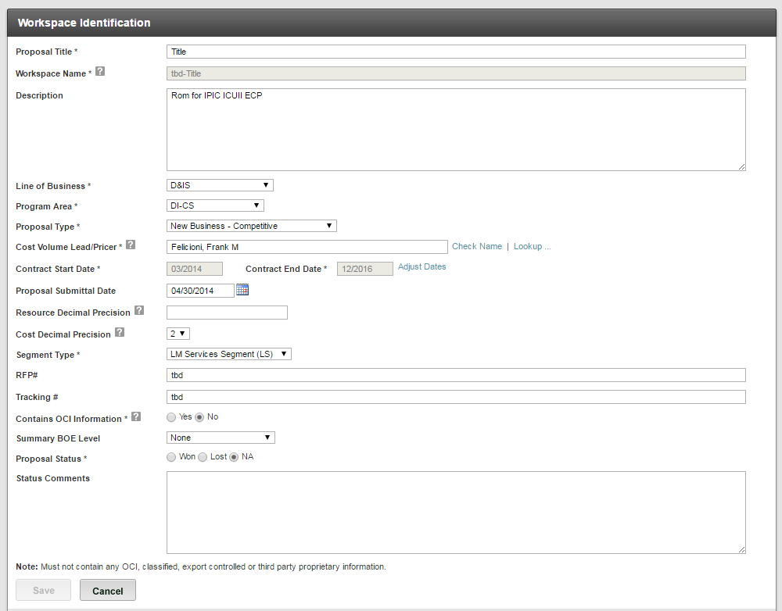

Options for Summary BOE Level:
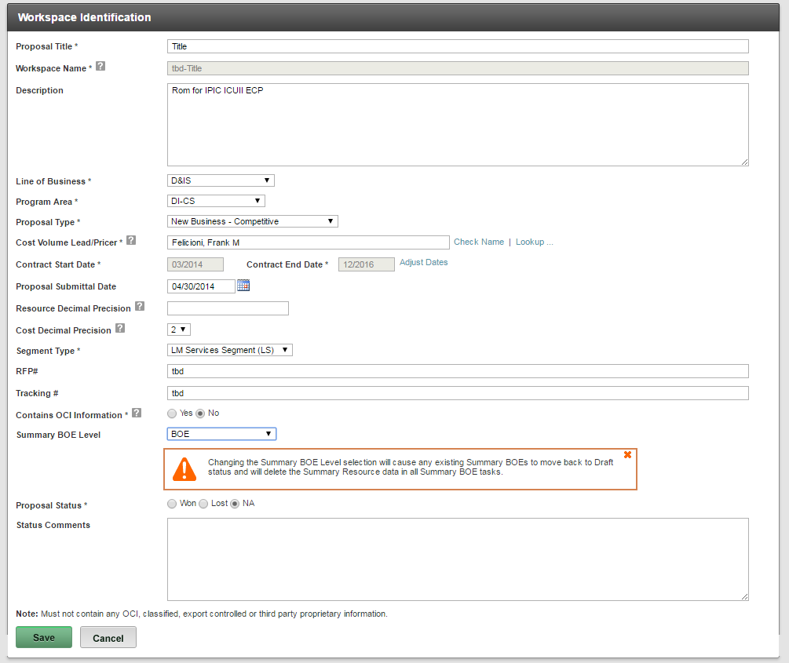
- BOE
- WBS
- CLIN
- Resource
- Performing Organization
- Resource Level Custom Field
- Performing Organization Level Custom Field
- Task Element Custom Field

Summary BOE – Manage BOE Page:

Before a Summary BOE Level is selected at Workspace level:
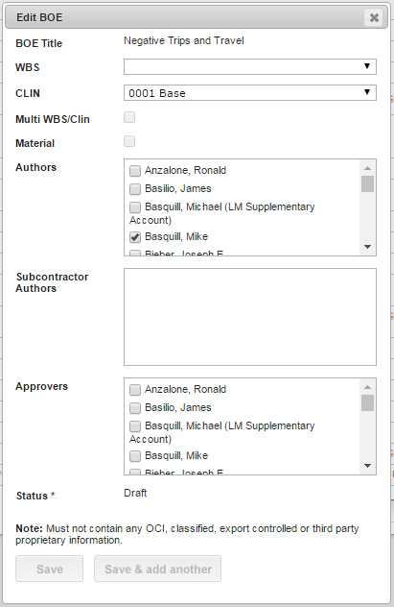

After a Summary Level is selected at the Workspace level:
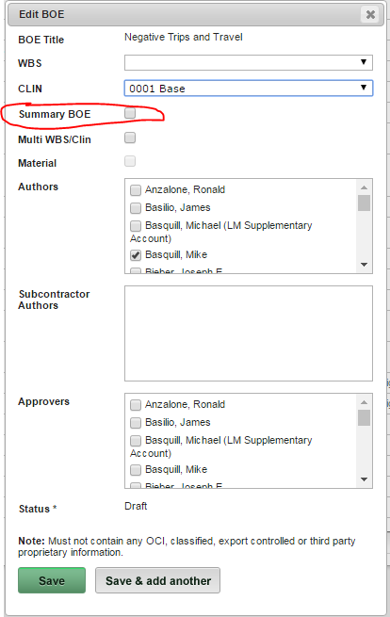

Summary BOEs:
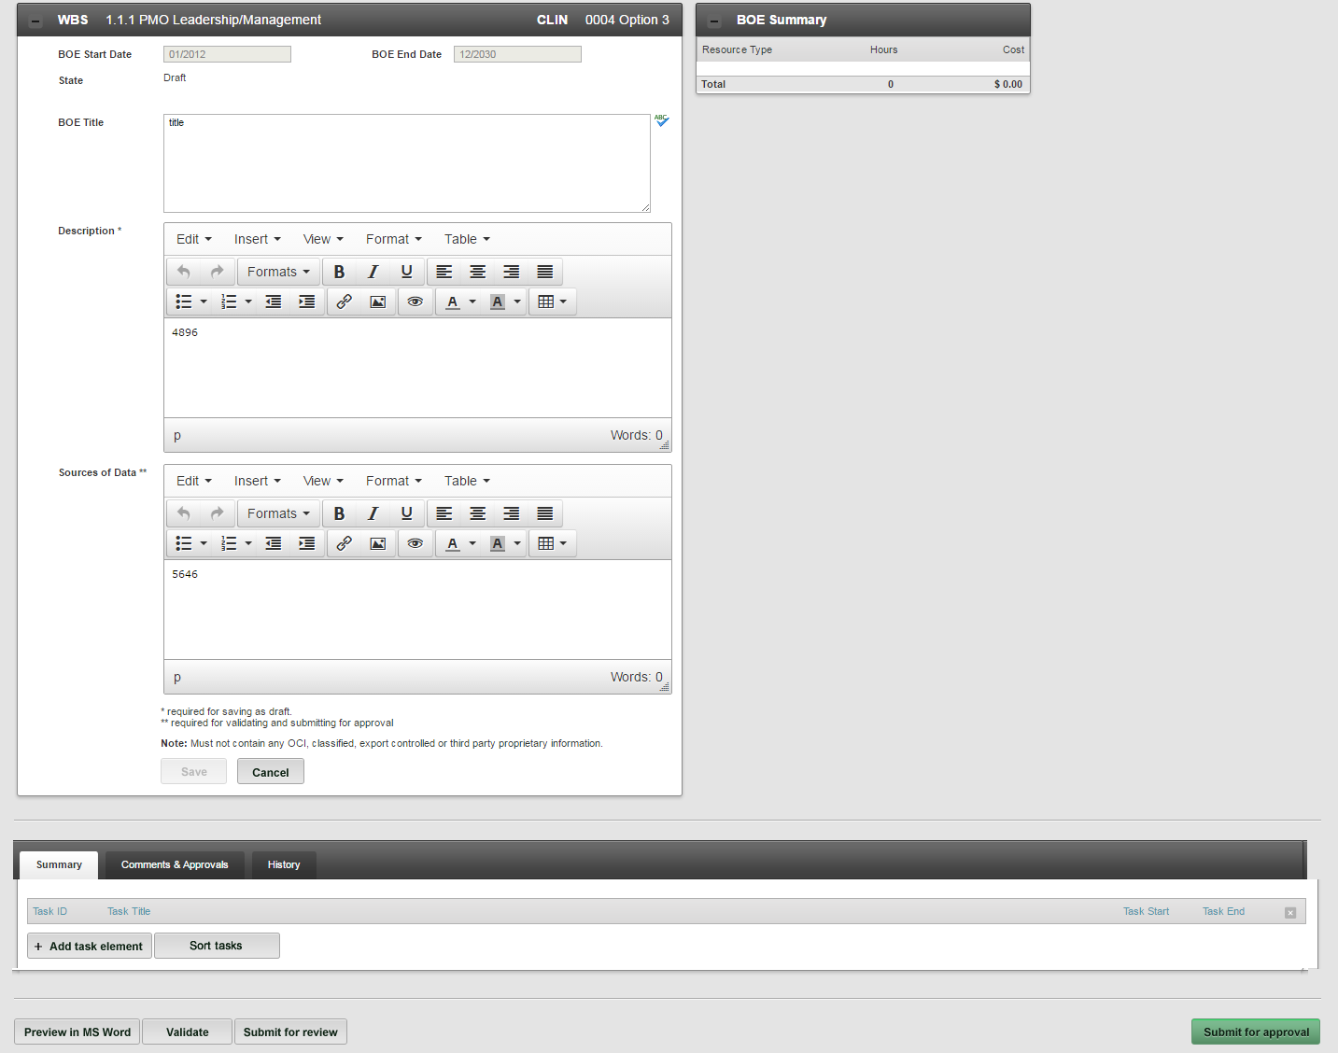

Notable differences:
- Summary BOE Start Date and End Date are synced with the workspace contract dates
- Summary BOE Task Elements Start Date and End Dates are synced with the workspace contract dates
- Ability to adjust BOE dates is removed from Summary BOEs (see above)
- The ODC and Travel Tabs are removed from Summary BOEs

Summary BOE Task Elements:

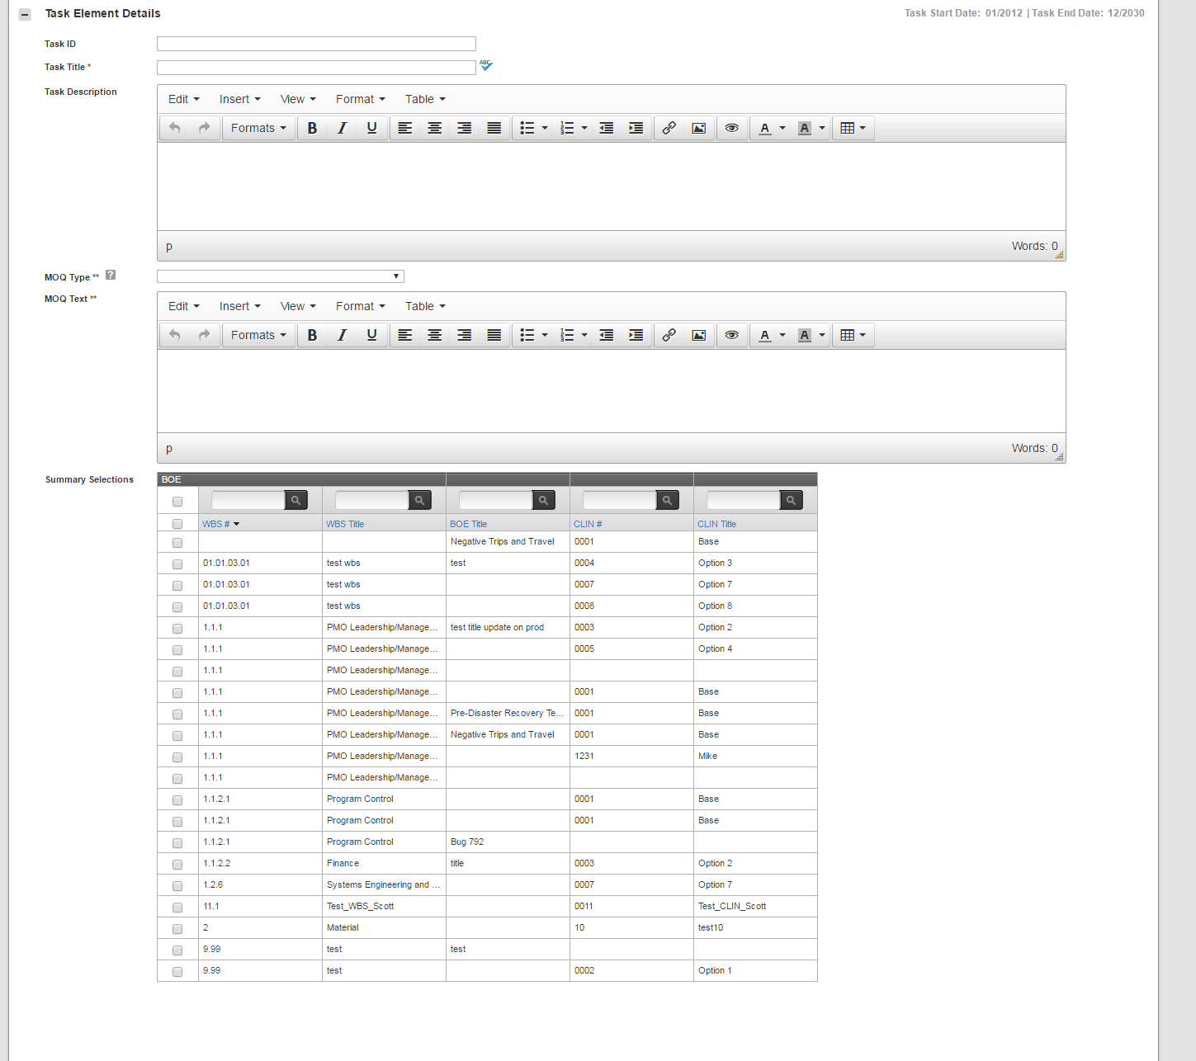

Notable Features:
- Summary BOE Task does not have an MOQ Equation
- BOE and Task Level Custom fields will not apply to Summary BOEs/Tasks
- Summary Selections section shows to be summarized in the task
- Start Dates and End dates are not adjustable

Summary BOE Task Element Grid:
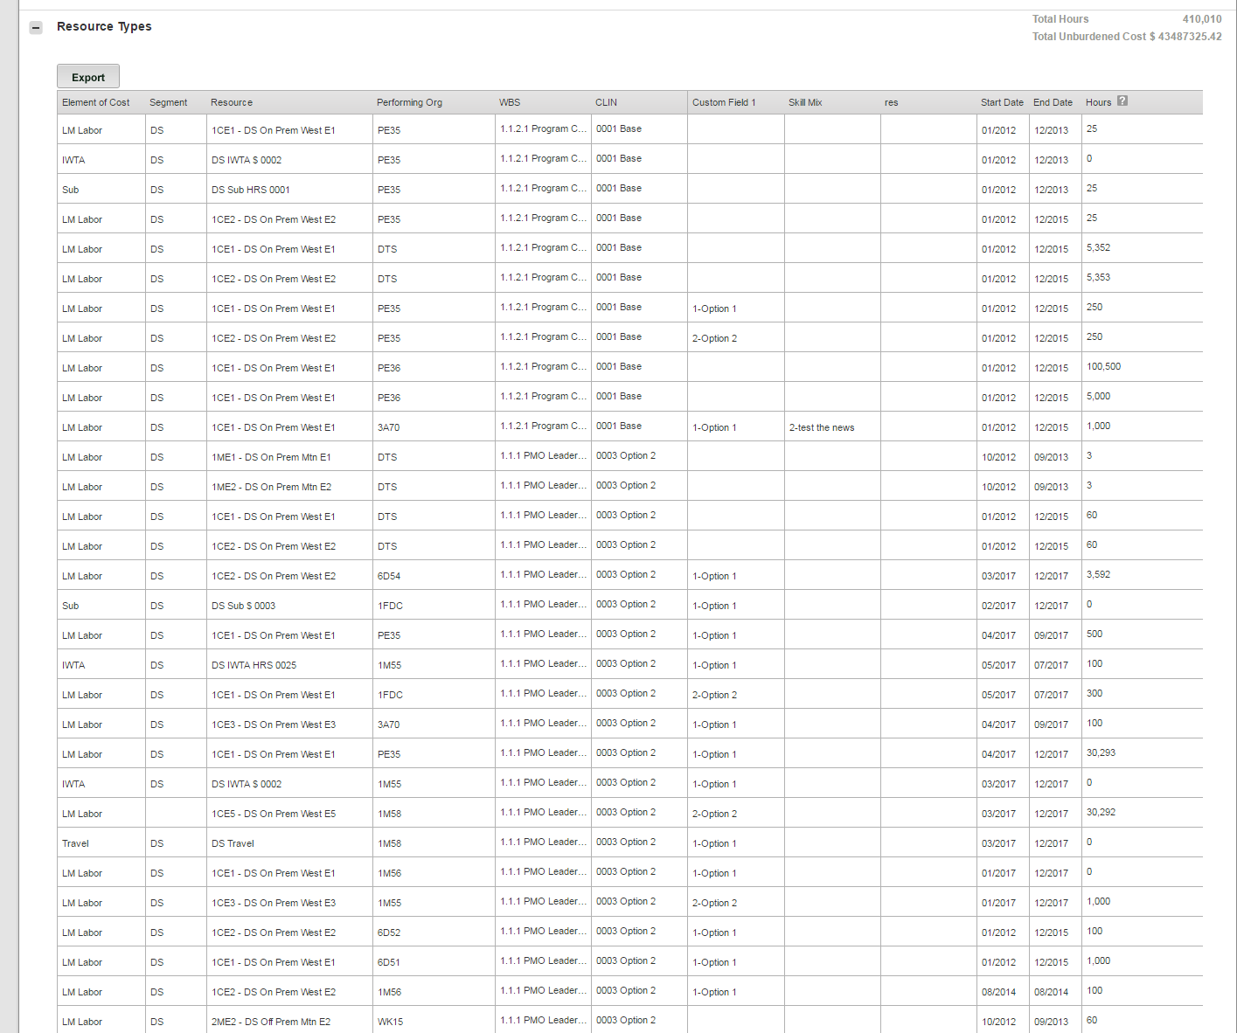
Notable Features:
- Grid is read only
- Information is pulled from summarized items

Summary BOE Reports:

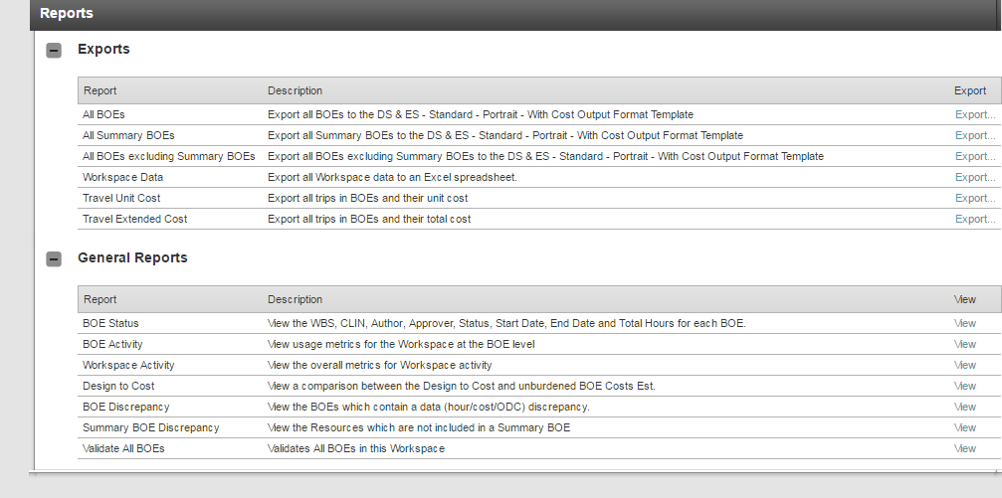

- New Reports added for Summary BOE
- New Exports added for Summary BOE

